Internship Report
On
Python Full Stack Development
Submitted To
School of Computer Science and Engineering
IILM University, Greater Noida, U.P.
In partial fulfilment of the requirement of degree of
B.Tech CSE

By
Roll Number of Student: CS-23411016
Name of Student: MOHD KAIF
Batch: 2026-27

CANDIDATE'S DECLARATION
I, MOHD KAIF, do hereby declare that the internship report titled “Python Full Stack Development” has been completed by me to fulfil the requirement for the award of the degree of Bachelor of Technology in CSE. All the references have been quoted and I have not taken as such any material from any other source. I affirm to you that this report is my own and has not been submitted to any other institute for any degree/diploma requirement and further I shall be solely responsible for any kind of copyright violation in this regard.

Student Name: MOHD KAIF
Roll No.: CS-23411016

ACKNOWLEDGEMENT
I am using this opportunity to express my gratitude to everyone who supported me throughout the Internship Program. I am thankful for their aspiring guidance, invaluably constructive criticism and friendly advice during this work. I am sincerely grateful to them for sharing their truthful and illuminating views on a number of issues related to this work.
I would like to thank EduSkills Academy and AICTE for providing the opportunity to undergo this Virtual Internship Program under the National Internship Portal, and IILM University, Greater Noida, for their continuous support and encouragement.
I express my gratitude to my parents for their blessings.

Student Name: MOHD KAIF
Roll No.: CS-23411016

TABLE OF CONTENTS
Candidate's Declaration i
Acknowledgement ii
Table of Contents iii
List of Figures iv
List of Tables iv
Internship Completion Certificate v

4. Project Description 1
4.1 Introduction 1
4.2 Organization Profile 1
4.3 Problem Statement 1
4.4 Project Objectives 1
4.5 Scope of the Project 2
4.6 Technologies and Tools Used 2
4.7 System Architecture 3
4.8 Database Design (ER Diagram) 3
4.9 Methodology 4
4.10 Sample Code 5
4.11 Screenshots 6
4.12 Expected Outcomes / Learning Outcomes 6
4.13 Conclusion and Future Scope 6
4.14 Certificates of Completion and Communication Proof 6
5. Bibliography / References 8

LIST OF FIGURES
Fig. 4.1 System Architecture Diagram 3
Fig. 4.2 Entity-Relationship (ER) Diagram 4
Fig. 4.3 Week-wise Methodology Flow 4

LIST OF TABLES
Table 4.1 Technologies and Tools Used 3
Table 4.2 Week-wise Internship Schedule 4
Table 4.3 Weekly Progress / Internship Log 8

INTERNSHIP COMPLETION CERTIFICATE
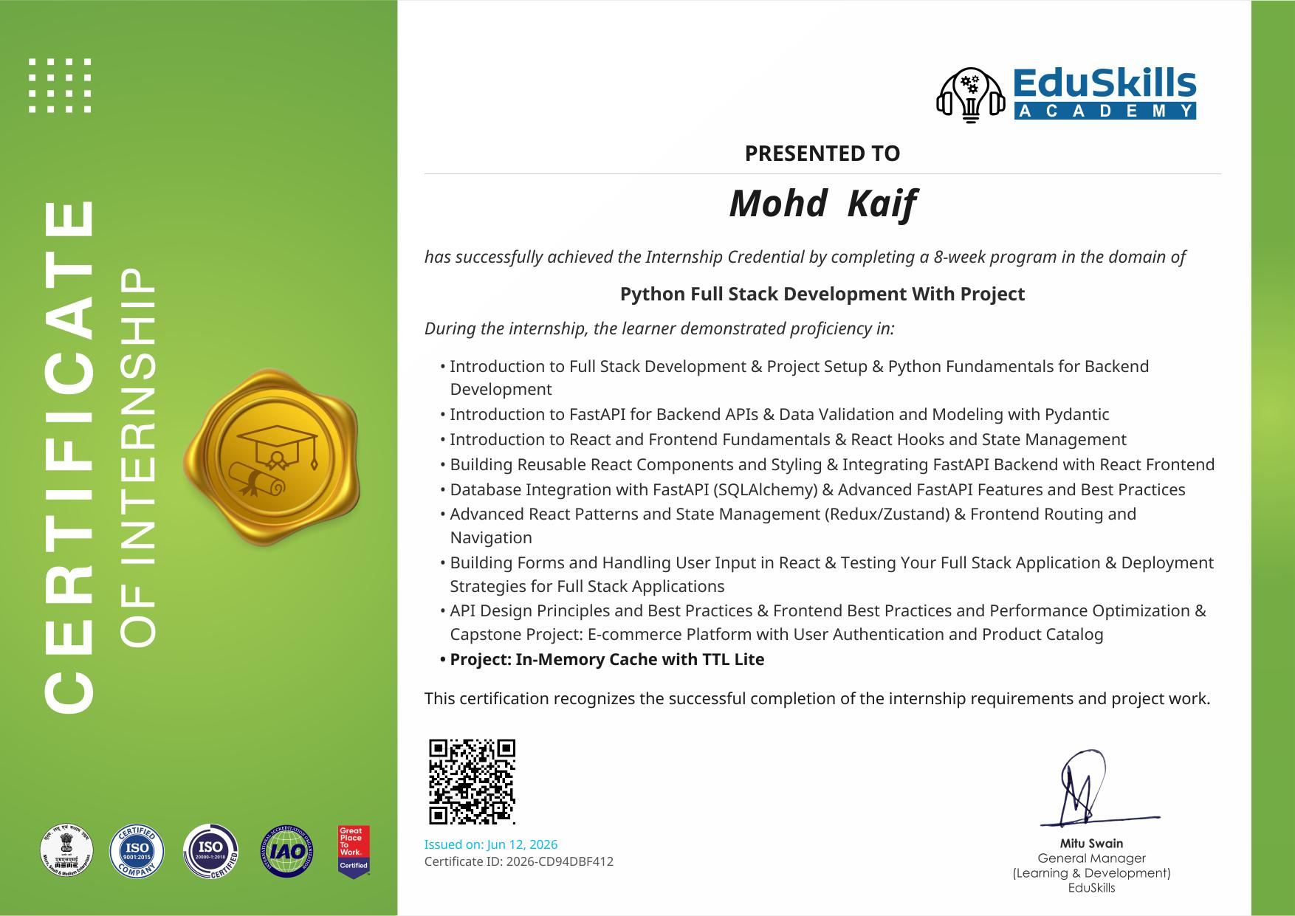

4. PROJECT DESCRIPTION

4.1 Introduction
This report presents the work carried out during an 8-week AICTE – EduSkills Virtual Internship in Python Full Stack Development, undertaken from April 2026 to June 2026 as part of the B.Tech (Computer Science and Engineering) curriculum at IILM University, Greater Noida. The internship followed a structured, week-wise curriculum covering backend development with Python and FastAPI, frontend development with React, database integration using SQLAlchemy, and modern software engineering practices such as testing and deployment. The program concluded with the design and development of a capstone full-stack e-commerce application and a supplementary mini-project, an in-memory cache with time-to-live (TTL) support.

4.2 Organization Profile
The internship was conducted under the AICTE – EduSkills Virtual Internship Program, a national initiative supported by the All India Council for Technical Education (AICTE) under its National Internship Portal, in collaboration with EduSkills Academy. EduSkills Academy is an ISO-certified skilling organisation that partners with academia and industry to deliver structured, industry-relevant virtual internship programs aimed at enhancing the employability of engineering students across India.

4.3 Problem Statement
Traditional academic curricula often provide limited hands-on exposure to the complete lifecycle of building and deploying a full-stack web application. Students frequently learn backend and frontend concepts in isolation, without experiencing how they integrate into a single, production-style system. This internship was designed to address that gap by requiring the design, development, and integration of a complete full-stack application — combining a Python-based backend, a React-based frontend, a relational database, authentication, and deployment considerations — within a structured eight-week timeline.

4.4 Project Objectives
The key objectives of the internship and the associated capstone project were:
- To gain proficiency in Python fundamentals, including data types, functions, and object-oriented programming, as a foundation for backend development.
- To design and build RESTful backend APIs using the FastAPI framework, with request validation and data modelling using Pydantic.
- To develop a responsive, component-based frontend using React, including hooks, state management, and routing.
- To integrate the frontend and backend, enabling dynamic data exchange through API calls.
- To design and integrate a relational database using SQLAlchemy ORM for persistent data storage and CRUD operations.
- To apply advanced React patterns and state management solutions such as Redux/Zustand for scalable frontend architecture.
- To implement testing strategies and understand deployment techniques for full-stack applications.
- To build a capstone e-commerce platform with user authentication and a product catalog, and a supporting in-memory cache utility with TTL support.

4.5 Scope of the Project
The scope of the internship project covers the end-to-end development of a full-stack e-commerce web application. On the backend, the scope includes API design, request handling, data validation, and database integration. On the frontend, the scope includes building reusable UI components, managing application state, handling user input through forms, and implementing client-side routing and navigation. The scope also extends to a supplementary systems-level mini-project — an in-memory cache with TTL (time-to-live) support — which reinforces backend fundamentals such as data structures and expiry management. Deployment considerations and testing practices were studied but implemented at a proof-of-concept level, appropriate to the scale of an academic internship.

4.6 Technologies and Tools Used
Table 4.1 summarises the primary technologies and tools used across the backend, frontend, database, and deployment layers of the project.
Table 4.1: Technologies and Tools Used
Category | Technology / Tool
Backend Language & Framework | Python, FastAPI
Data Validation | Pydantic
Frontend Library | React (Hooks, Components, Routing)
State Management | Redux / Zustand
Database & ORM | SQLAlchemy (relational database)
Testing | Backend and frontend testing frameworks
Deployment | Docker, cloud deployment platforms
Version Control | Git / GitHub

4.7 System Architecture
The capstone application follows a three-tier full-stack architecture, illustrated in Fig. 4.1. The presentation layer (React) communicates with the application layer (FastAPI) over REST/JSON, which in turn accesses the data layer (SQLAlchemy ORM over a relational database). An in-memory TTL cache sits alongside the application layer to reduce repeated database lookups for frequently accessed data.
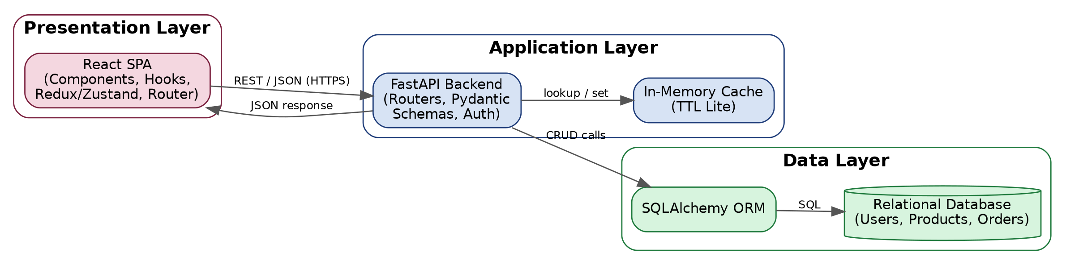
Fig. 4.1: System Architecture Diagram
- Presentation Layer: A React single-page application responsible for rendering the UI, managing client-side state, and handling routing and navigation.
- Application Layer: A FastAPI backend exposing RESTful endpoints for authentication, product catalog management, and order processing, with validation via Pydantic models, and a TTL cache for hot-path lookups.
- Data Layer: A relational database accessed through the SQLAlchemy ORM, storing user, product, and order data.

4.8 Database Design (ER Diagram)
Fig. 4.2 shows the relational schema designed for the capstone e-commerce platform. A user can place multiple orders; each order consists of one or more order items, and each order item references a product from the catalog.
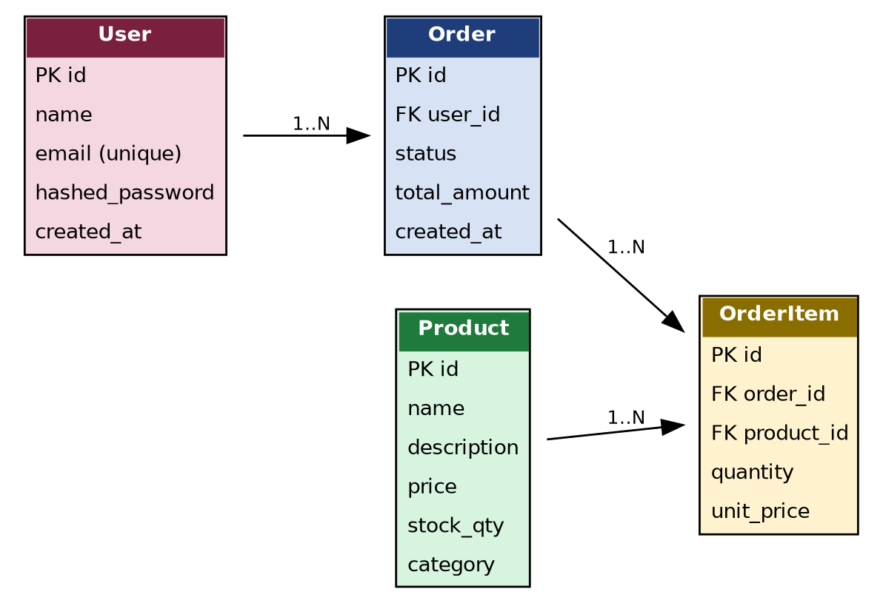
Fig. 4.2: Entity-Relationship (ER) Diagram

4.9 Methodology
The project was developed incrementally over the eight weeks of the internship, following the week-wise curriculum structure summarised in Table 4.2 and Fig. 4.3. Backend fundamentals were covered first, followed by API development and data validation, then frontend fundamentals, database integration, advanced state management, testing/deployment, and finally the capstone build.
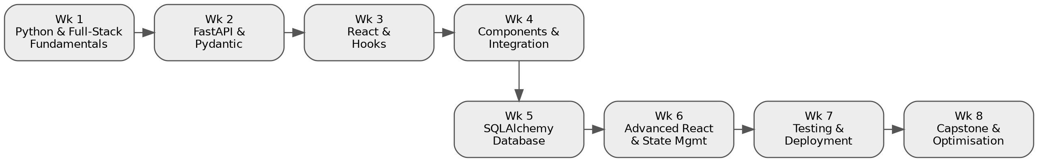
Fig. 4.3: Week-wise Methodology Flow
Table 4.2: Week-wise Internship Schedule
Week | Module | Description
1 | Introduction to Full Stack & Python Fundamentals | Full-stack concepts, environment setup, Python data types, functions, OOP, backend basics.
2 | FastAPI & Data Validation (Pydantic) | Backend APIs with FastAPI – request handling, routing, dependency injection, validation.
3 | React Fundamentals & Hooks | React basics – components, JSX, props, useState, useEffect, dynamic UIs.
4 | Reusable Components & Frontend-Backend Integration | Reusable React components integrated with the FastAPI backend via API calls.
5 | Database Integration with SQLAlchemy | SQLAlchemy ORM, CRUD operations, models, relational database connectivity.
6 | Advanced React & State Management | Advanced patterns, React Router, Redux/Zustand for scalable applications.
7 | Testing & Deployment | Backend/frontend testing strategies; deployment with Docker and cloud platforms.
8 | API Design, Frontend Optimisation & Capstone Project | Full e-commerce application – FastAPI backend, database, auth, React frontend.

4.10 Sample Code
The following snippets illustrate two representative pieces of the implementation: a FastAPI route handler used in the capstone e-commerce backend, and the core logic of the In-Memory Cache with TTL Lite mini-project.
(a) FastAPI Route – Creating a Product
@router.post("/products", response_model=ProductOut, status_code=201)
def create_product(payload: ProductCreate, db: Session = Depends(get_db)):
product = Product(**payload.model_dump())
db.add(product)
db.commit()
db.refresh(product)
return product

(b) In-Memory Cache with TTL Lite – Core Class
class TTLCache:
"""A minimal in-memory cache with per-key time-to-live (TTL)."""

def __init__(self, default_ttl: float = 60.0):
self._store: dict[str, tuple[Any, float]] = {}
self.default_ttl = default_ttl

def set(self, key: str, value: Any, ttl: float | None = None) -> None:
expiry = time.monotonic() + (ttl or self.default_ttl)
self._store[key] = (value, expiry)

def get(self, key: str) -> Any | None:
item = self._store.get(key)
if item is None:
return None
value, expiry = item
if time.monotonic() > expiry:
del self._store[key] # lazy expiry
return None
return value
def delete(self, key: str) -> None:
self._store.pop(key, None)

The cache uses lazy expiry: rather than running a background sweep, an expired key is detected and removed the next time it is accessed, keeping the implementation simple and dependency-free while still bounding memory growth for short-lived entries.

4.11 Screenshots
This section is reserved for screenshots of the running application (e.g. login page, product catalog, cart/checkout flow, and API documentation generated by FastAPI at /docs). Insert screenshots captured from your local run of the project here before final submission.

4.12 Expected Outcomes / Learning Outcomes
Upon completion of the internship, the following outcomes were achieved:
- A working understanding of building and consuming RESTful APIs using FastAPI.
- Practical experience in building responsive, component-based user interfaces using React.
- The ability to integrate a frontend application with a backend API and a relational database.
- A functional capstone e-commerce platform demonstrating user authentication and product catalog management.
- A working in-memory cache utility implementing TTL-based expiry (“In-Memory Cache with TTL Lite”).
- Familiarity with testing and deployment strategies for full-stack applications.

4.13 Conclusion and Future Scope
The internship provided practical, end-to-end exposure to full-stack web development — from backend API design and database modelling to frontend UI development and state management — within a structured eight-week program. The resulting capstone e-commerce platform and the In-Memory Cache with TTL Lite project demonstrate the core competencies expected of a full-stack developer. As future scope, the platform could be extended with features such as payment gateway integration, role-based access control, containerised deployment on a cloud platform, and replacing the in-memory cache with a distributed cache (e.g. Redis) for multi-instance deployments.

4.14 Certificates of Completion and Communication Proof
The following pages contain the Internship Offer Letter issued by EduSkills Academy under the AICTE National Internship Portal, confirming the internship domain, duration, and structure.
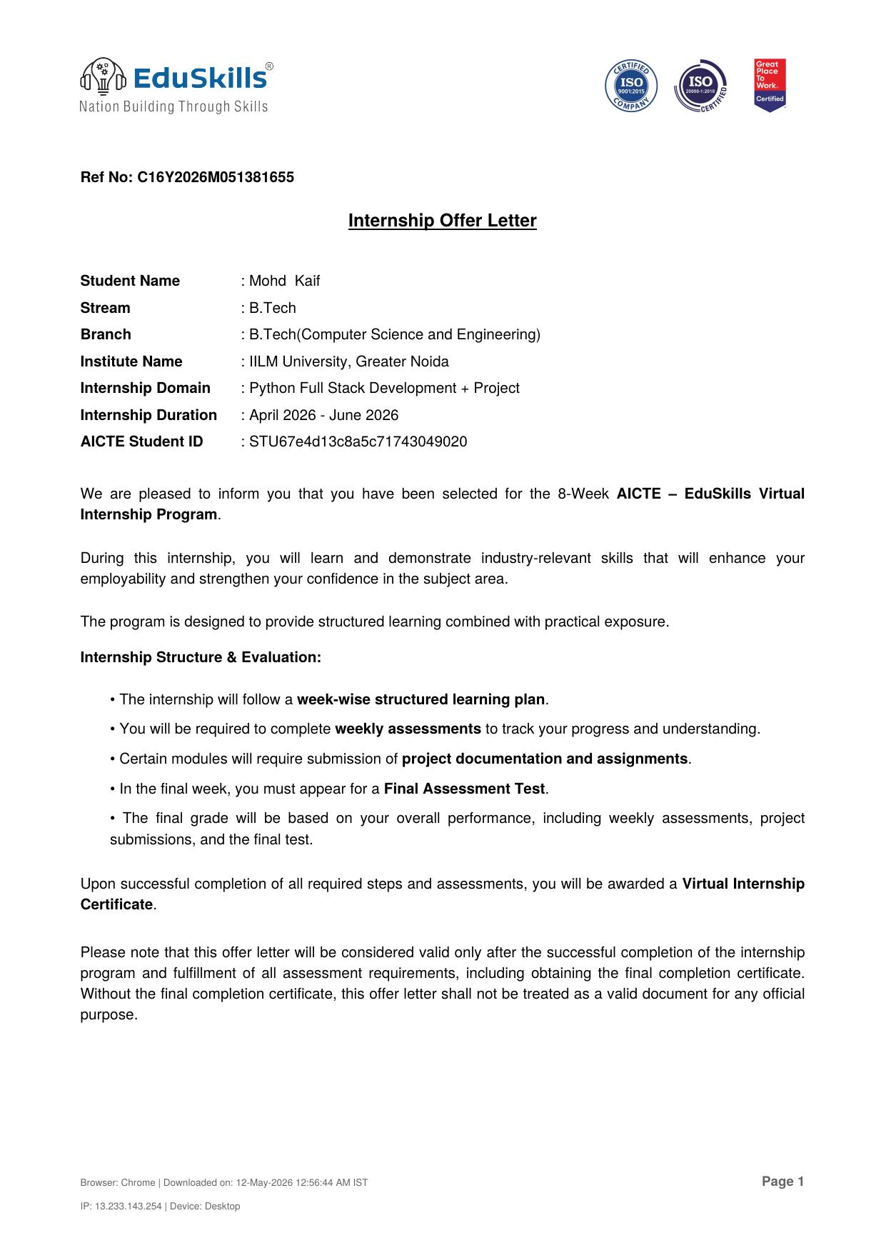
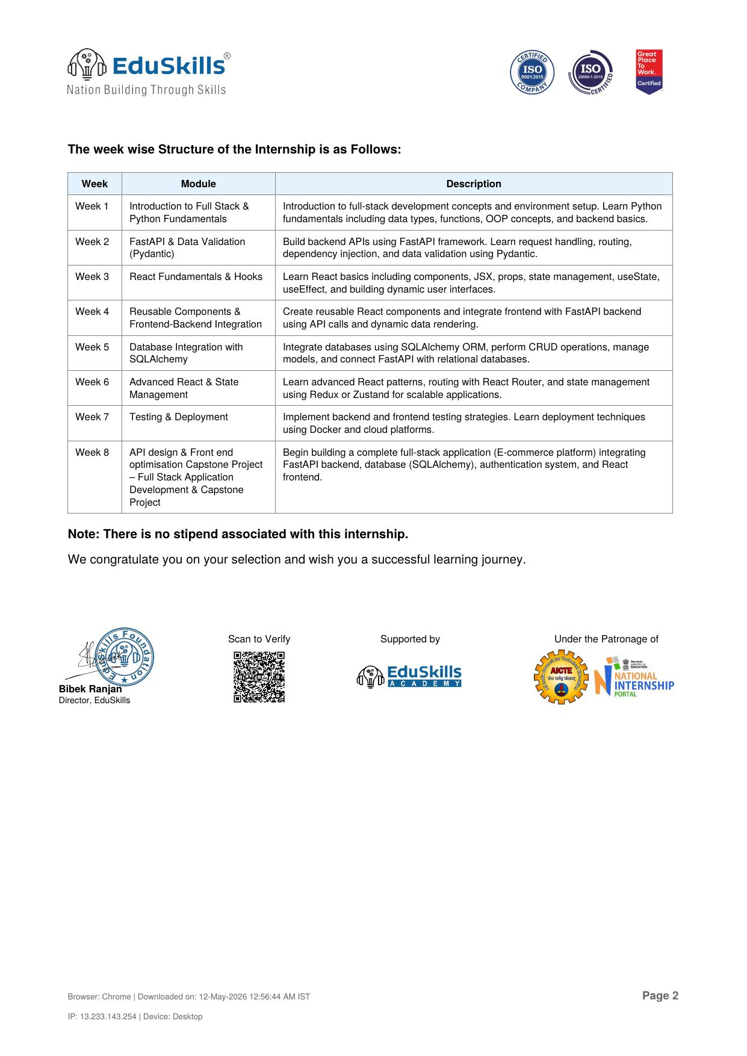

Table 4.3 records a brief weekly log of work completed during the internship.
Table 4.3: Weekly Progress / Internship Log
Week | Work Completed | Outcome
1 | Set up development environment; revised Python fundamentals and OOP concepts. | Environment ready; Python basics reinforced.
2 | Built first FastAPI routes; learned Pydantic-based request/response validation. | Working REST endpoints with validation.
3 | Learned React components, JSX and hooks; built static UI screens. | Basic React UI components created.
4 | Connected React frontend to FastAPI endpoints; built reusable components. | End-to-end data flow between frontend and backend.
5 | Integrated SQLAlchemy models; implemented CRUD operations on the database. | Persistent storage for users and products.
6 | Added Redux/Zustand state management and React Router navigation. | Multi-page app with consistent global state.
7 | Wrote unit tests; explored Docker-based deployment. | Verified functionality; containerised build.
8 | Built the capstone e-commerce module and the In-Memory Cache with TTL Lite project; final assessment. | Completed capstone project and mini-project; internship concluded.

5. BIBLIOGRAPHY / REFERENCES
[1] FastAPI, FastAPI Documentation. Available: https://fastapi.tiangolo.com/. Accessed: July 2026.
[2] React, React Documentation. Available: https://react.dev/. Accessed: July 2026.
[3] SQLAlchemy, SQLAlchemy Documentation. Available: https://www.sqlalchemy.org/. Accessed: July 2026.
[4] Pydantic, Pydantic Documentation. Available: https://docs.pydantic.dev/. Accessed: July 2026.
[5] Redux Toolkit, Redux Toolkit Documentation. Available: https://redux-toolkit.js.org/. Accessed: July 2026.
[6] Zustand, Zustand Documentation. Available: https://zustand-demo.pmnd.rs/. Accessed: July 2026.
[7] Docker Inc., Docker Documentation. Available: https://docs.docker.com/. Accessed: July 2026.
[8] EduSkills Foundation, AICTE Virtual Internship Program – Internship Offer Letter, Ref. No. C16Y2026M051381655, 2026.
[9] EduSkills Foundation, Certificate of Internship, Certificate ID: 2026-CD94DBF412, Issued on 12 June 2026.

